Toy 1.xx

By Eric Lemmon

*Dedicated to Eduardo’s Metronome Samples*

Documentation:

**Step 1:**

Download Python 3.x for your respective system software. This program has not been tested on linux or windows, so Mac OSX is probably the safest bet to get it operational. You can find the latest version of 3.x Python here: <https://www.python.org/downloads/>

**Step 2:**

Down the files for the program: <https://github.com/eclemmon/Toy1>

You will need to edit the file pathways of the samples in the program if you are doing this from scratch. Email Eric if you don’t know how at ec.lemmon@gmail.com

**Step 3:**

Install Python, open up your system’s terminal/bash/console. For macs, go to “applications” 🡪 “utilities” 🡪 and double click on “terminal”.

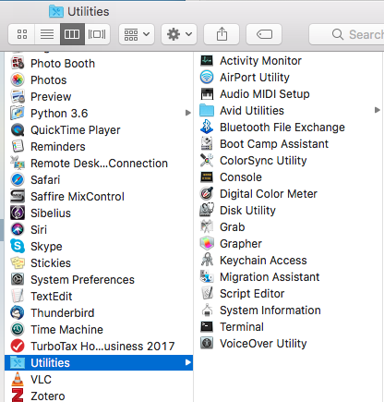

**Step 4:**

Once in terminal, determine which computer will be the chat server and who will be the chatters. The server will have additional steps.

**Step 4.1 (SERVER ONLY):**

The server computer needs to open up their computer’s network settings. In mac, you go to system preferences and click on network. After that click on ‘advanced’ and the at the top click on TCP/IP. Look at the IPv4 setting for your computer, and record this number with the periods exactly.

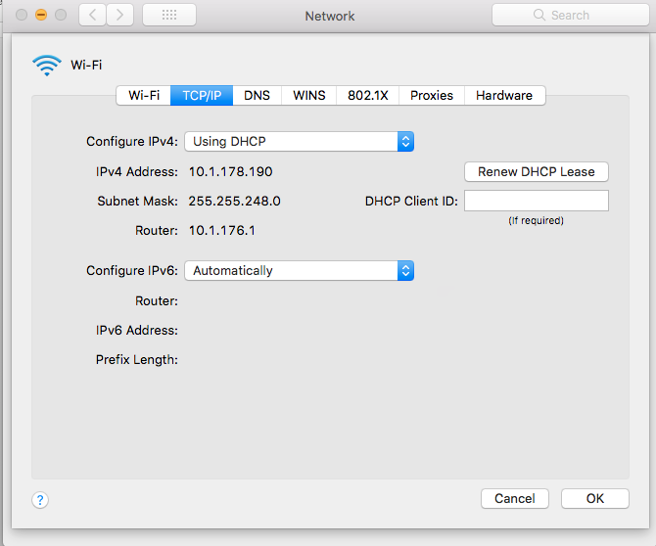

**Step 4.2 (SERVER ONLY):**

Go back to your terminal and type in with spaces and customized to your system’s environment “python3 <file pathway to pychat_server.py> <IPv4 address>”. You can get the file pathway to pychat_server.py by simply starting by typing in python3 and then dragging the file from the folder you downloaded into the terminal window. After that simply type in the IPv4 number you recorded earlier.

After hitting enter the program will boot after a second or so and your terminal should look something like this:

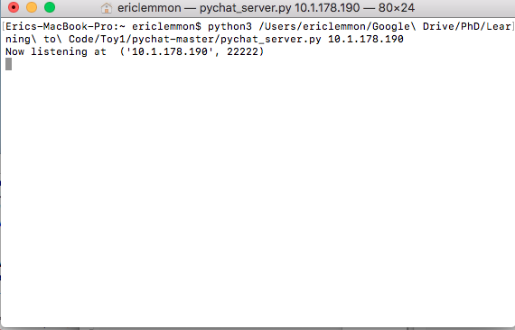

**Step 5 (Clients):**

Go to your terminal and type in with spaces and customized to your system’s environment “python3 <file pathway to pychat_client.py> <IPv4 address>”. You can get the file pathway to pychat_server.py by simply starting by typing in python3 and then dragging the file from the folder you downloaded into the terminal window. After that simply type in the IPv4 number you received from the server operator. After hitting enter, you should see something like this:

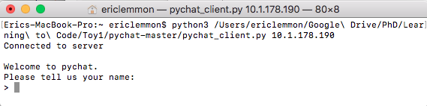

*Type away and enjoy!*

Chat client and server code from Xiayun Sun and used under an MIT License.

<https://github.com/xysun>